Retail assignment:
Task : A retail company receives daily order files from its sales application.
The source application uploads CSV files into an Azure Storage Account.
Snowflake should automatically load the new files whenever they arrive in Azure Storage.
Step A:-> Snowflake setup
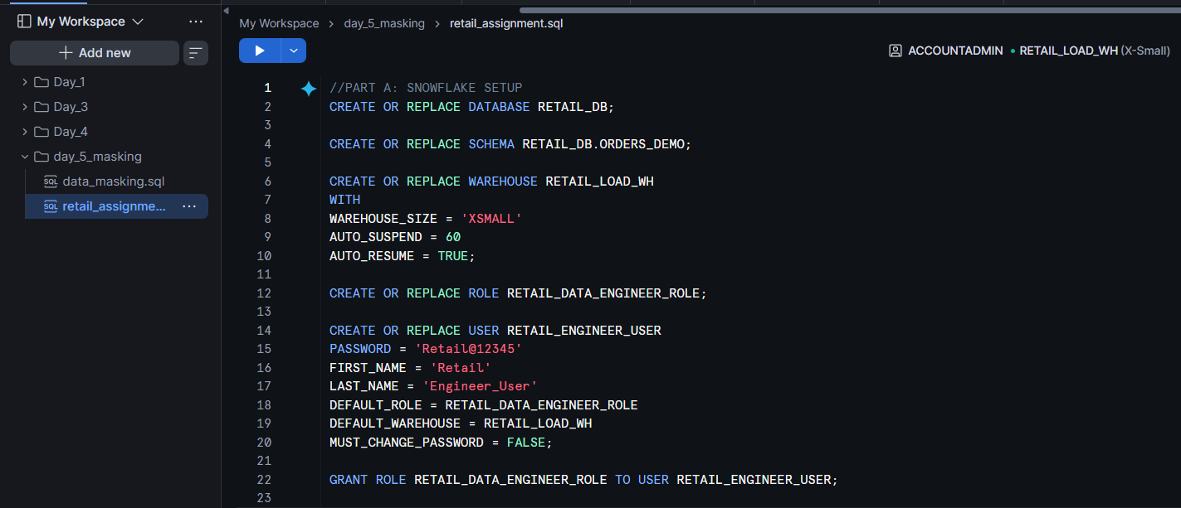

Step B : Azure storage Setup
Create storage account -> snowflakeday5
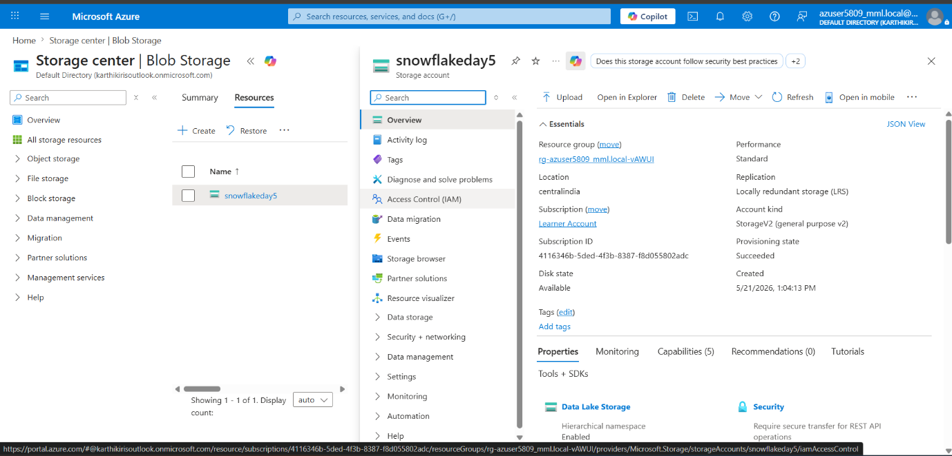
Create container -> retail-data
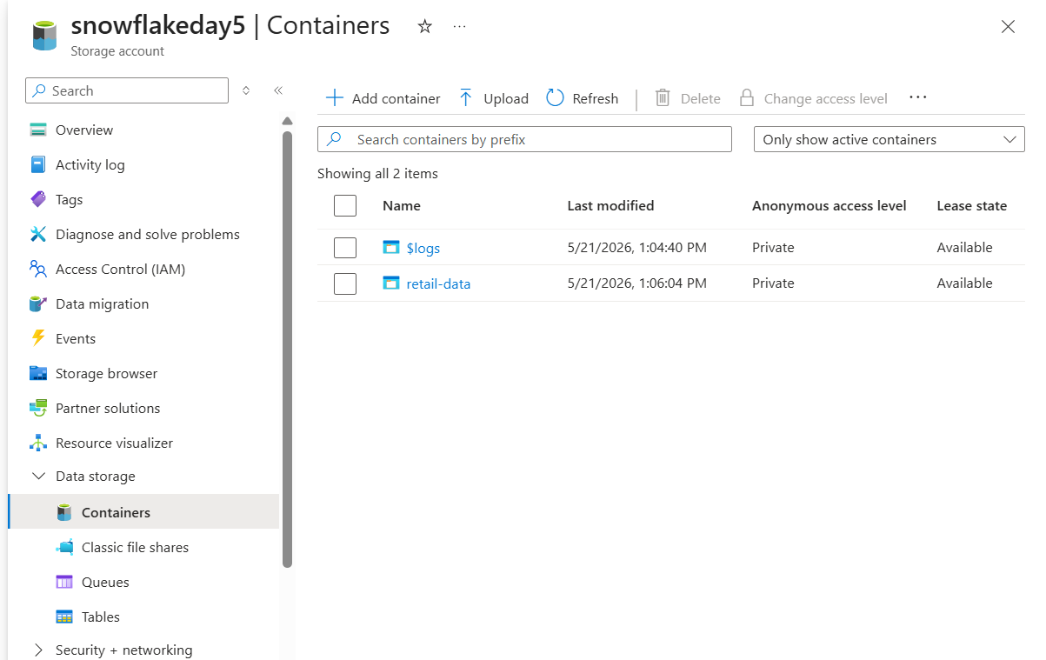
Add directory ->raw/orders
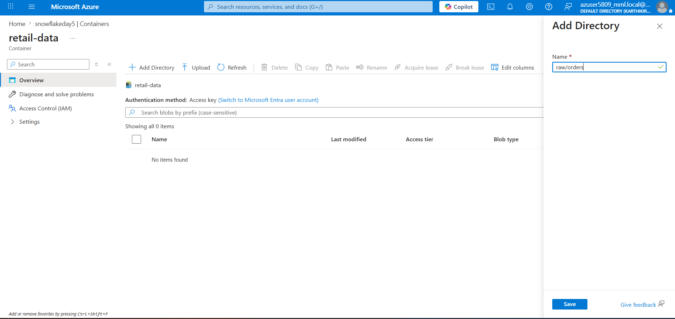
Upload csv files in orders
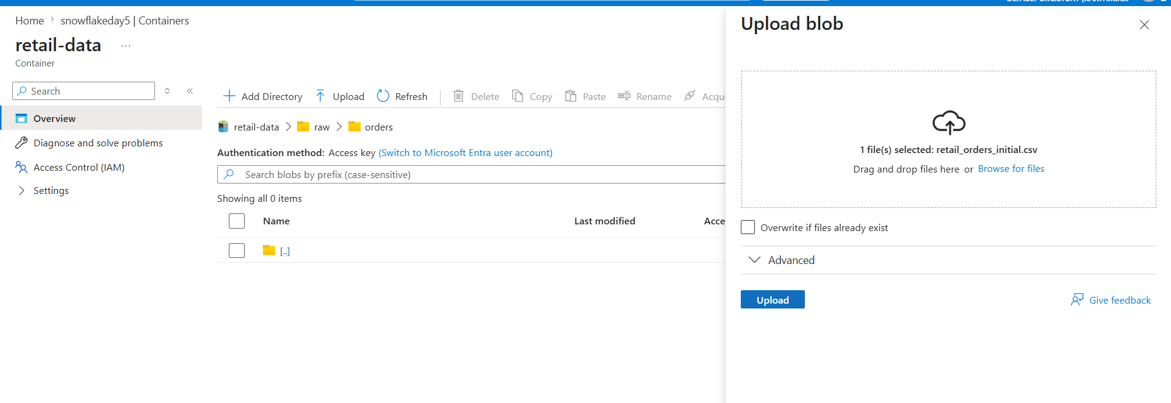

Step C: Snowflake external setup
Create file format for CSV.
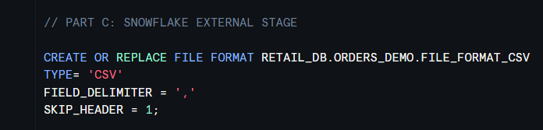
Create an Azure storage integration or external stage.
we have learner account so we generate sas(shared access signature) token
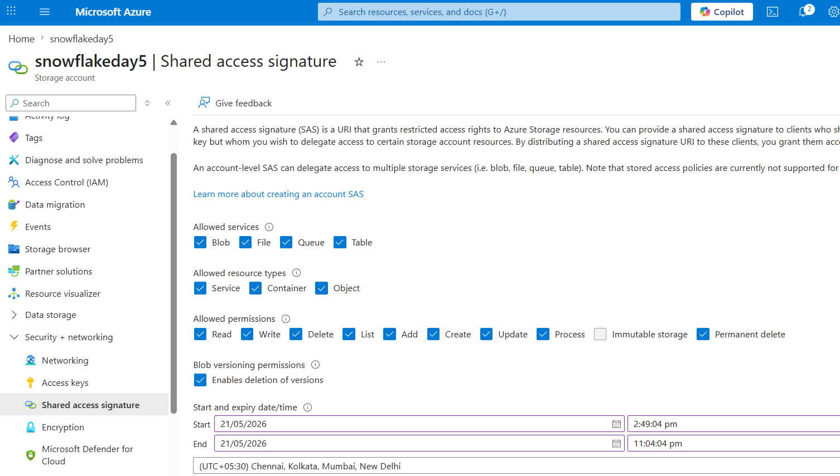
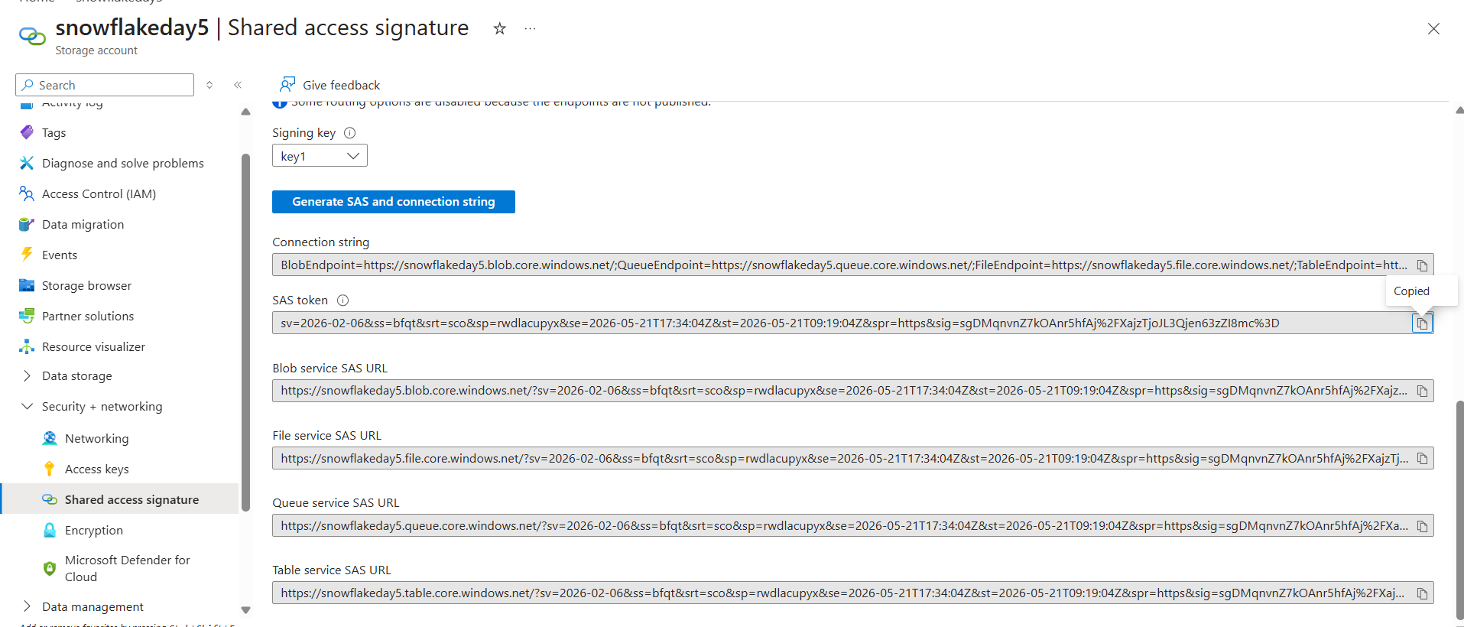
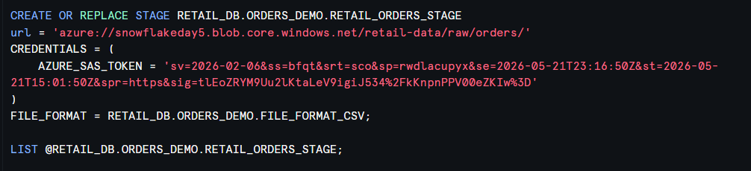

Step D: Initial Data Load
Create raw landing table ORDERS_RAW.
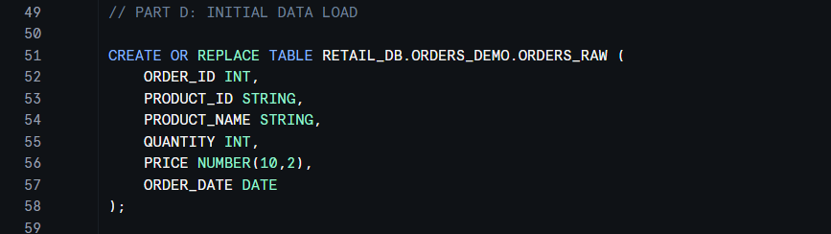
Create final table named ORDERS_FINAL.
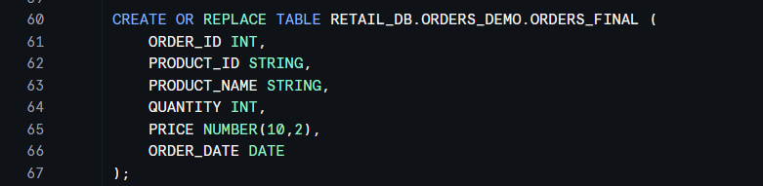
Load the initial file from your Azure Stage into ORDERS_RAW
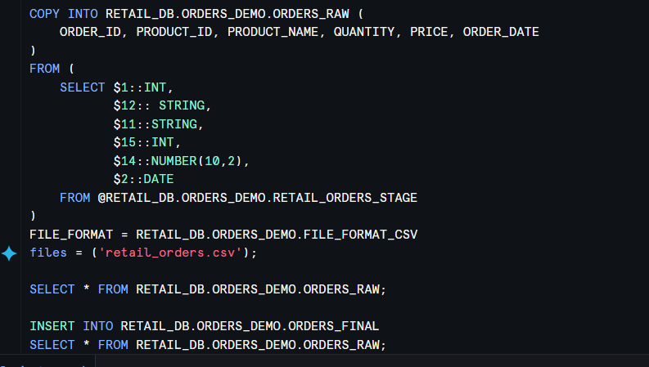

Step E : Incremental Loading
- Create the Snowpipe
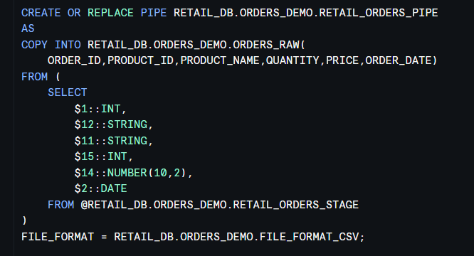
2.Create a stream on ORDERS_RAW.
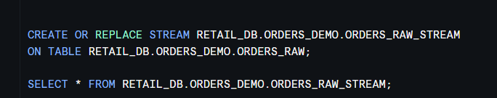
3.Create a task to merge new rows from the stream into ORDERS_FINAL
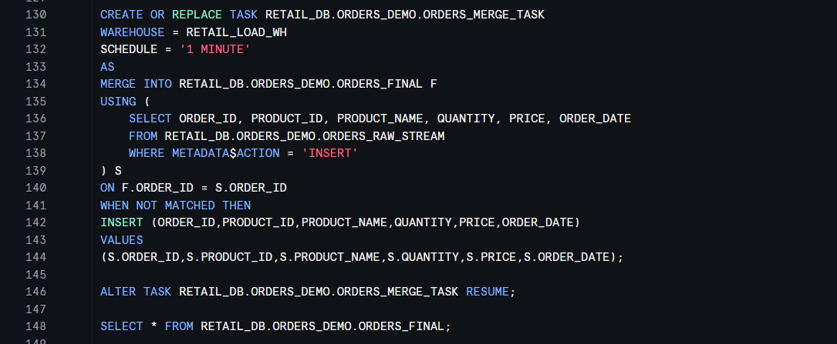

Upload new data file
